# Task 1

Open ​​<https://www.facebook.com/>

Capture the below text and verify text contains the below text

Facebook helps you connect and share with the people in your life

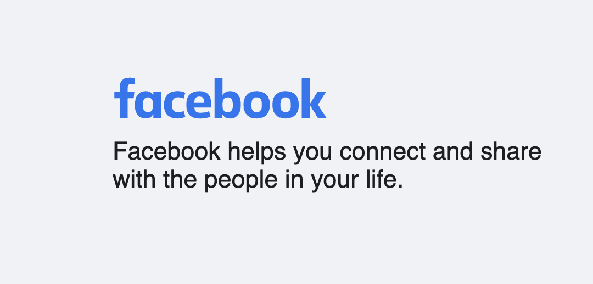

**package** assignment8;

**import** org.openqa.selenium.By;

**import** org.openqa.selenium.WebDriver;

**import** org.openqa.selenium.chrome.ChromeDriver;

**public** **class** Task1 {

**public** **static** **void** main(String[] args) **throws** InterruptedException {

// Capture the below text and verify text contains the below text

WebDriver driver = **new** ChromeDriver();

driver.get("https://www.facebook.com/");

Thread.*sleep*(2000);

// -//div[@class='_8esl']

String expText="Facebook helps you connect and share with the people in your life";

String actualText = driver.findElement(By.*xpath*("//div[@class='_8esl']//h2")).getText();

System.***out***.println(actualText);

**if**(actualText.contains(expText)) {

System.***out***.println("Passed");

}

**else** {

System.***out***.println("Failed");

}

driver.quit();

}

}

# Task2

Open ​​<https://www.facebook.com/>

Capture all link text available in the footer section and verify Create Page Link is present or not. If yes then click on it.

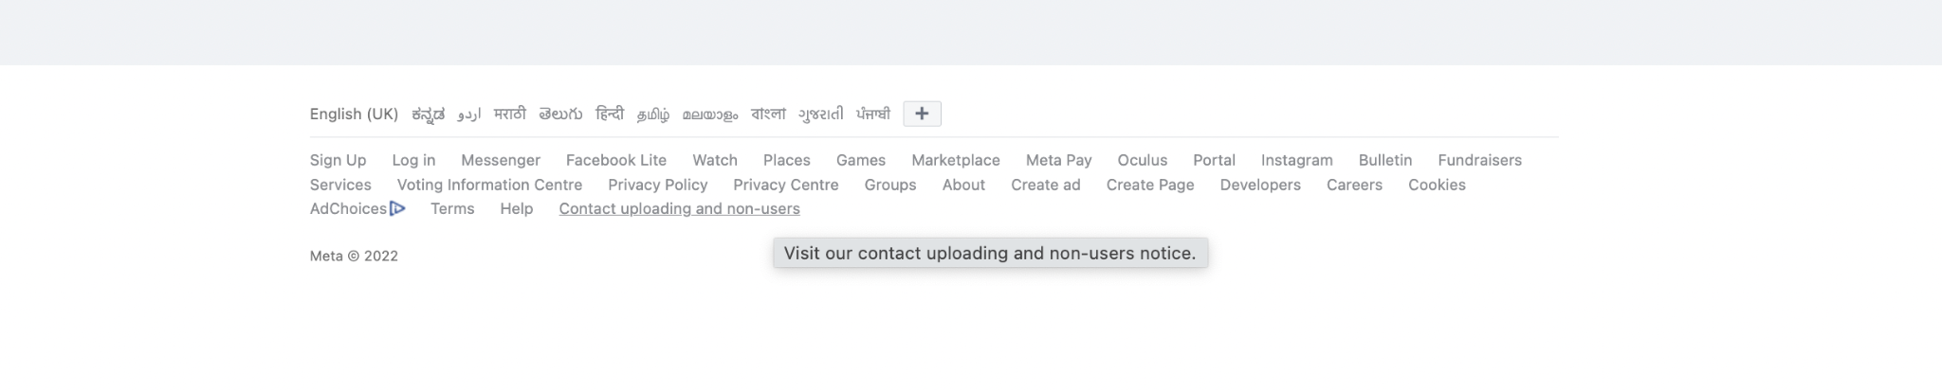

package assignment8;

import java.util.List;

import org.openqa.selenium.By;

import org.openqa.selenium.WebDriver;

import org.openqa.selenium.WebElement;

import org.openqa.selenium.chrome.ChromeDriver;

public class Task2 {

public static void main(String[] args) throws InterruptedException {

// Capture all link text available in the footer section and verify Create Page Link is present or not.

//If yes then click on it.

WebDriver driver = new ChromeDriver();

driver.get("https://www.facebook.com/");

driver.manage().window().maximize();

Thread.sleep(2000);

List<WebElement> allLinks = driver.findElements(By.xpath("//div[@id='pageFooter']//a"));

System.out.println("Size of all links are :"+allLinks.size());

for(WebElement links : allLinks) {

System.out.println(links.getText());

if(links.getText().equals("Create Page")) {

links.click();

break;

}

}

WebElement header = driver.findElement(By.xpath("//div[@data-testid='pageCreationHeaderBannerTitle']"));

System.out.println("Header of Create Page is :"+header.getText());

driver.quit();

}

}

# Task 3

Note- Please use only xpath in this scenario

Open <https://www.facebook.com/>

Click on Create new account

Fill in all details and click on the Signup button

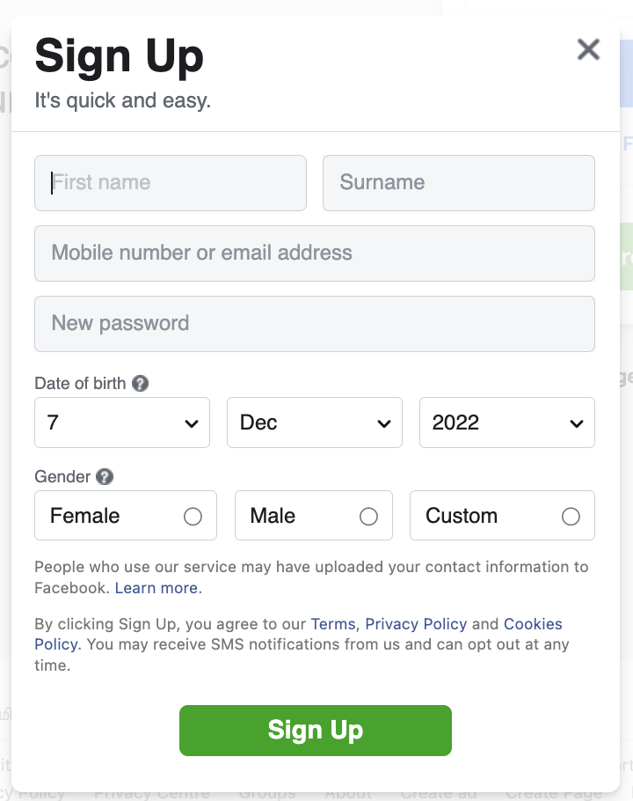

package assignment8;

import java.util.List;

import org.openqa.selenium.By;

import org.openqa.selenium.WebDriver;

import org.openqa.selenium.WebElement;

import org.openqa.selenium.chrome.ChromeDriver;

import org.openqa.selenium.support.ui.Select;

public class Task3 {

public static void main(String[] args) throws InterruptedException {

// Click on Create new account

//Fill in all details and click on the Signup button

WebDriver driver = new ChromeDriver();

driver.get("https://www.facebook.com/");

driver.manage().window().maximize();

Thread.sleep(2000);

driver.findElement(By.xpath("//a[text()='Create New Account']")).click();

Thread.sleep(2000);

driver.findElement(By.xpath("//input[@name='firstname']")).sendKeys("Saurabh");

driver.findElement(By.xpath("//input[@name='lastname']")).sendKeys("Sahu");

driver.findElement(By.xpath("//input[contains(@aria-label,'Mobile number')]")).sendKeys("saurabh@gmail.com");

driver.findElement(By.xpath("//input[contains(@aria-label,'Re-enter email address')]")).sendKeys("saurabh@gmail.com");

driver.findElement(By.xpath("//input[@id='password_step_input']")).sendKeys("saurabh@123");

WebElement date = driver.findElement(By.xpath("//select[@aria-label='Day']"));

Select selectDate = new Select(date);

selectDate.selectByVisibleText("25");

WebElement month = driver.findElement(By.xpath("//select[@aria-label='Month']"));

Select selectMonth = new Select(month);

selectMonth.selectByVisibleText("Apr");

WebElement year = driver.findElement(By.xpath("//select[@aria-label='Year']"));

Select selectYear = new Select(year);

selectYear.selectByVisibleText("1996");

driver.findElement(By.xpath("//label[text()='Male']")).click();

driver.findElement(By.xpath("//button[@name='websubmit']")).click();

Thread.sleep(10000);

driver.quit();

}

}

# Task 4

Perform same steps which you did in task 3 but replace all xpath with css Selectors.

package assignment8;

import java.util.List;

import org.openqa.selenium.By;

import org.openqa.selenium.WebDriver;

import org.openqa.selenium.WebElement;

import org.openqa.selenium.chrome.ChromeDriver;

import org.openqa.selenium.support.ui.Select;

public class Task4 {

public static void main(String[] args) throws InterruptedException {

// Click on Create new account

//Fill in all details and click on the Signup button - using css

WebDriver driver = new ChromeDriver();

driver.get("https://www.facebook.com/");

driver.manage().window().maximize();

Thread.sleep(2000);

driver.findElement(By.cssSelector("a[data-testid^='open-registration']")).click();

Thread.sleep(2000);

driver.findElement(By.cssSelector("input[name='firstname']")).sendKeys("Shubham");

driver.findElement(By.cssSelector("input[name='lastname']")).sendKeys("Paul");

driver.findElement(By.cssSelector("input[aria-label*='Mobile number']")).sendKeys("shubhamp@gmail.com");

driver.findElement(By.cssSelector("input[aria-label*='Re-enter email address']")).sendKeys("shubhamp@gmail.com");

driver.findElement(By.cssSelector("input[id='password_step_input']")).sendKeys("shubham@123");

WebElement date = driver.findElement(By.cssSelector("select[aria-label='Day']"));

Select selectDate = new Select(date);

selectDate.selectByVisibleText("25");

WebElement month = driver.findElement(By.cssSelector("select[aria-label='Month']"));

Select selectMonth = new Select(month);

selectMonth.selectByVisibleText("Apr");

WebElement year = driver.findElement(By.cssSelector("select[aria-label='Year']"));

Select selectYear = new Select(year);

selectYear.selectByVisibleText("1996");

driver.findElement(By.cssSelector("span[data-name='gender_wrapper'] span:nth-child(2)")).click();

driver.findElement(By.cssSelector("button[name='websubmit']")).click();

Thread.sleep(10000);

driver.quit();

}

}